Eksamen 22
Assignment 1
a)
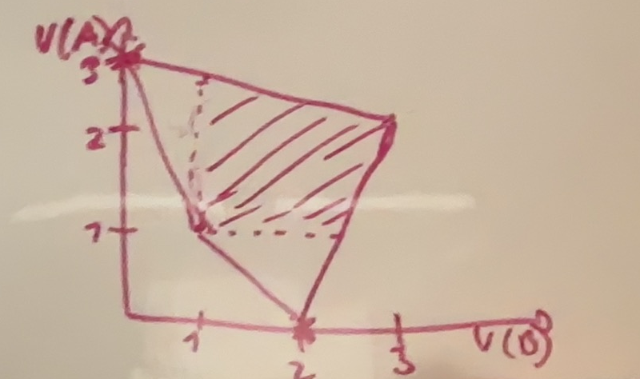

b)

its preffered if both players dont want to deviate in the first round (since if they will want to deviate in a later round there is always a greater gain in doing it in the first one
so the discountfactor must be prefered for both

B: Bo gets his absolutely highest payoff meaning he will never have incentive to deviate

A:
$$U_{A}\left(dont deviate\right)=\frac{2}{1-δ}≥3+\frac{δ}{1-δ}=U_{A}(deviate)$$
$$\frac{2}{1-δ}≥3+\frac{δ}{1-δ}$$
$⇕$ Uligheden løses for delta vha. WordMat.
$$δ≥\frac{1}{2} ∧ δ≤1$$
It is a SPNE for $δ≥\frac{1}{2}$

c)
A alternates between high and low, as long as B plays H. play low forever if he plays L
B plays H as long as A alternates, plays low forever otherwise
Giving A
$$\overline{v}=\left(1-δ\right)·\left(\sum_{i=0}^{∞}{3δ^{2·i}}+\sum_{i=0}^{∞}{2·δ^{2·i+1}}\right)=\left(1-δ\right)\left(\frac{3}{1-δ^{2}}+δ·\frac{2}{1-δ^{2}}\right)$$
$$=\frac{3}{1+δ}+\frac{2δ}{1+δ}$$
For $δ$ tæt på 1 $≈\frac{3}{2}+\frac{2}{2}=2.5$

d)
already gave it above:
A alternates between high and low, as long as B plays H. play low forever if he plays L
B plays H as long as A alternates, plays low forever otherwise

There must be no incentive to deviate
B will only ever deviate in the low state giving the utility inequality we need to evaluate
$$U_{B}\left(deviate\right)=\frac{1}{1-δ}≤\frac{δ3}{1-δ^{2}}=U_{B}\left(dont deviate\right)$$
$$⇔1≤\frac{3δ}{1+δ}$$
$$⇔δ≥\frac{1}{2}$$
Anna will only want to deviate in from high to low so we evaluate the inequality in the same way
$$U_{A}\left(deviate\right)=3+\sum_{i=1}^{∞}{δ^{i}}≤\sum_{i=0}^{∞}{2δ^{2i}}+\sum_{i=0}^{∞}{3δ^{2i+1}}=\sum_{i=0}^{∞}{2δ^{i}}+\sum_{i=0}^{∞}{δ^{2i+1}}=U_{A}(dont deviate)$$
$$⇔3+\frac{δ}{1-δ}≤\frac{2}{1-δ}+\frac{δ}{1-δ^{2}}$$
$$3·\left(1-δ\right)+δ≤2+\frac{δ}{1+δ}$$
$⇕$
$$δ≥\frac{\sqrt{3}-1}{2}$$

$$\frac{\sqrt{3}-1}{2}<\frac{1}{2}$$
Thus we just need
$$δ≥\frac{1}{2}$$
For the strategy profile to be a SPNE

Assignment 2

($D,I)$ is EQ with $(f,r)$
$(I,D)$not EQ since weak prefers Indirect
$(D,D)$ not EQ since weak strictly prefers Indirect

$(I,I)$ is eq with either r or f depending or p
Prefers r in I if and only if
$$2p≥-p+\left(1-p\right)$$
$⇕$ Uligheden løses for p vha. WordMat.
$$p≥\frac{1}{4}$$
And $f$ otherwise
With f In D

Assignment 3
$$π_{H}=1000$$
$$π_{L}=400$$
$$p\left(W\right)=\frac{2}{3}$$
$$P\left(S\right)=\frac{1}{5}$$
$$u\left(C,e\right)=\sqrt{C}-g\left(e\right)$$
$$g\left(W\right)=8$$
$$g\left(S\right)=5$$
$$\overline{u}=0$$
$$Π\left(π,C\right)=π-C$$

a)
i) the worker must choose the contract rather than the outside option (PC)
$$p\left(e\right)·\left(v\left(C_{H}\right)-g\left(e\right)\right)+\left(1-p\left(e\right)\right)\left(v\left(C_{L}\right)-g\left(e\right)\right)≥\overline{u}=0$$
Since the firm can pay enorece the ontract we dont need incentive compatability
ii)
in this setting the PC must be binding othersise simply decrease the compensation and increase expected profits
$$\max_{C_{L},C_{H}}{\frac{2}{3}·\left(1000-C_{H}\right)+\frac{1}{3}\left(400-C_{L}\right)}$$
$$s.t\frac{2}{3}·\left(\sqrt{C_{H}}-8\right)+\frac{1}{3}\left(\sqrt{C_{L}}-8\right)≥0$$
$$L=\frac{2}{3}·\left(1000-C_{H}\right)+\frac{1}{3}\left(400-C_{L}\right)+λ\left(\frac{2}{3}·\left(\sqrt{C_{H}}-8\right)+\frac{1}{3}\left(\sqrt{C_{L}}-8\right)\right)$$
$$\frac{∂L}{∂C_{H}}=-\frac{2}{3}+λ·\frac{2}{3}·\frac{1}{2\sqrt{C_{H}}}=0$$
$$\frac{∂L}{∂C_{H}}=-\frac{1}{3}+\frac{1}{3}·λ·\frac{1}{2\sqrt{C_{L}}}=0$$
$$\frac{∂L}{∂λ}=0⇔\frac{2}{3}·\left(\sqrt{C_{H}}-8\right)+\frac{1}{3}\left(\sqrt{C_{L}}-8\right)=0$$

$$\left(1\right) And (2) ⇒C_{H}=C_{L}=C$$
$$(3)⇒\sqrt{C}-8=0⇔C=64$$
Constant compensation of 64

iii)
$$\max_{C_{L},C_{H}}{\frac{1}{5}·\left(1000-C_{H}\right)+\frac{4}{5}\left(400-C_{L}\right)}$$
$$s.t \frac{1}{5}·\left(\sqrt{C_{H}}-5\right)+\frac{4}{5}\left(\sqrt{C_{L}}-5\right)≥0$$
$$L=\frac{1}{5}·\left(1000-C_{H}\right)+\frac{4}{5}\left(400-C_{L}\right)+λ\left(\frac{1}{5}·\left(\sqrt{C_{H}}-5\right)+\frac{4}{5}\left(\sqrt{C_{L}}-5\right)\right)$$
$$\frac{∂L}{∂C_{H}}=-\frac{1}{5}+λ·\frac{1}{5}·\frac{1}{2\sqrt{C_{H}}}=0$$
$$\frac{∂L}{∂C_{H}}=-\frac{4}{5}+\frac{4}{5}·λ·\frac{1}{2\sqrt{C_{L}}}=0$$
$$\frac{∂L}{∂λ}=0⇔\frac{1}{5}·\left(\sqrt{C_{H}}-5\right)+\frac{4}{5}\left(\sqrt{C_{L}}-5\right)=0$$
$$\left(1\right)and \left(2\right)⇒C_{H}=C_{L}=C$$
$$\left(3\right)⇒\sqrt{C}-5=0⇔C=25$$
iv)
W:
$$\frac{2}{3}·\left(1000-64\right)+\frac{1}{3}\left(400-64\right)=736$$

S:
$$\frac{1}{5}·\left(1000-25\right)+\frac{4}{5}\left(400-25\right)=495$$

v) a firm should choose the option netting the largest utility
i.e implement ”W” netting $736$in profit

b)
i)
$$\max_{C_{H},C_{L}}{\frac{2}{3}·\left(1000-C_{H}\right)+\frac{1}{3}\left(400-C_{L}\right)}$$
$$\begin{aligned}s.t.\frac{2}{3}·\left(\sqrt{C_{H}}-8\right)+\frac{1}{3}\left(\sqrt{C_{L}}-8\right)≥0\#\left(PC\right)\end{aligned}$$
$$\begin{aligned}\frac{2}{3}·\left(\sqrt{C_{H}}-8\right)+\frac{1}{3}\left(\sqrt{C_{L}}-8\right)≥\frac{1}{5}·\left(\sqrt{C_{H}}-5\right)+\frac{4}{5}·\left(\sqrt{C_{L}}-5\right)\#\left(IC\right)\end{aligned}$$

ii)
At the lectures we have shown that in optimum of exactly this setting both must be binding giving us a simle system of equations to solve
Thinking about it it make great intuitive sense we want to make the difference in pay just big enough that he/she prefers the high effort option but not a pannie more, at the same time we a want to give him/her enogh that he actually takes the contract

$$\frac{2}{3}·\left(\sqrt{C_{H}}-8\right)+\frac{1}{3}\left(\sqrt{C_{L}}-8\right)=\frac{1}{5}·\left(\sqrt{C_{H}}-5\right)+\frac{4}{5}·\left(\sqrt{C_{L}}-5\right)$$
$$\frac{2}{3}·\left(\sqrt{C_{H}}-8\right)+\frac{1}{3}\left(\sqrt{C_{L}}-8\right)=0$$
$⇕$ Ligningssystemet løses for C_H,C_L vha. WordMat's 'Løs Ligninger' funktion,
$$\left(C_{H}=\frac{5041}{49} ∧ C_{L}=\frac{676}{49}\right)$$
$$C_{H}=\frac{5041}{49}≈102,877551$$
$$C_{L}=\frac{676}{49}≈13,7959184$$
iii) we realise that the First best solution works
$$C_{L}=C_{H}=25$$
Check PC
$$\frac{1}{5}\left(\sqrt{25}-5\right)+\frac{4}{5}·\left(\sqrt{25}-5\right)=0≥0$$

Check IC
$$\sqrt{25}-8=\frac{2}{3}·\left(\sqrt{C_{H}}-8\right)+\frac{1}{3}\left(\sqrt{C_{L}}-8\right)≤\frac{1}{5}·\left(\sqrt{C_{H}}-5\right)+\frac{4}{5}·\left(\sqrt{C_{L}}-5\right)=\sqrt{25}-5$$
$$⇔\sqrt{25}-8≤\sqrt{25}-5⇔-3≤0$$
Thus both inequalities are saisfied by the first best solution, sinve the second best is at most as ood as the first best one we know that the first best one is optimal

iv)
W:
$$\frac{2}{3}·\left(1000-\frac{5041}{49}\right)+\frac{1}{3}\left(400-\frac{676}{49}\right)≈726,8163265$$

S:
$$\frac{1}{5}·\left(1000-25\right)+\frac{4}{5}\left(400-25\right)=495$$

v)
the firm will implement W with compensation
$$C_{H}=\frac{5041}{49},C_{L}=\frac{676}{49}$$
Since this gives the firm the highest profit

c) the cost is exactly the difference in utility
$$736-726,8163265≈9,1836735$$

Problem 4

A)
All 100 cars will be owned by potential owners and current owners
Since the potential owner value both type of cars higher

b)
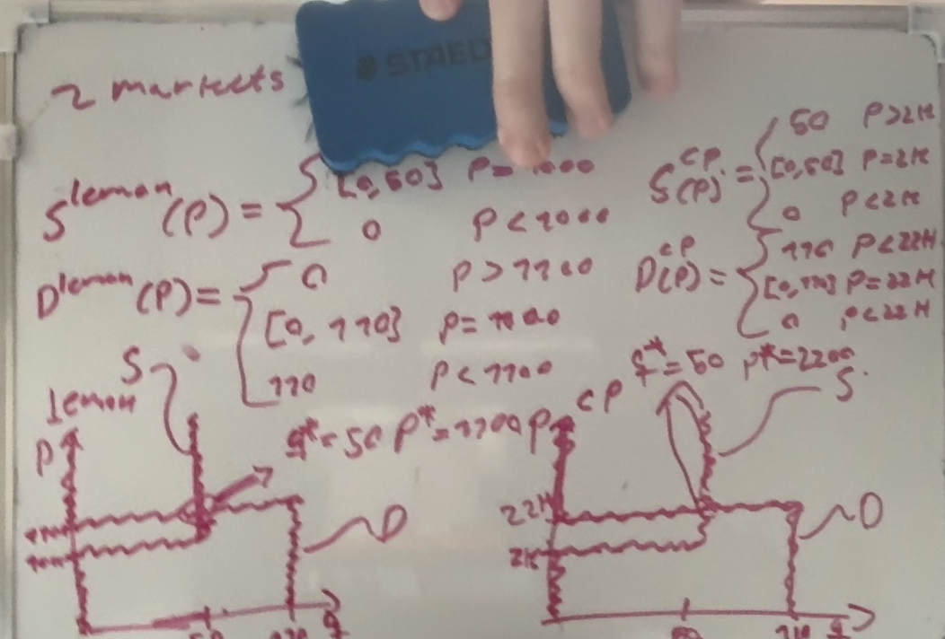
c)
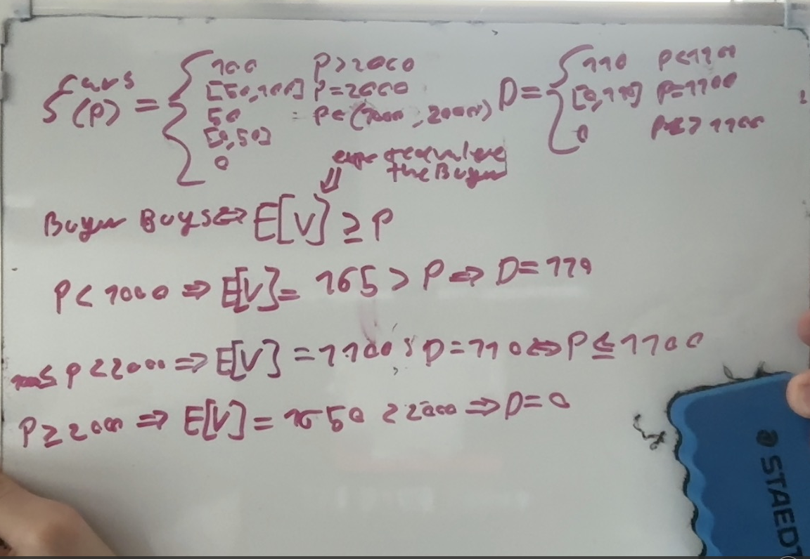

Plotted
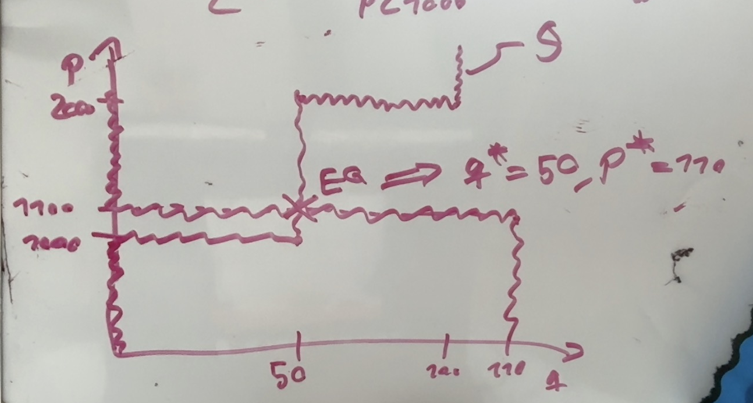

The 50 lemons are sold the 50 cream puffs are not

